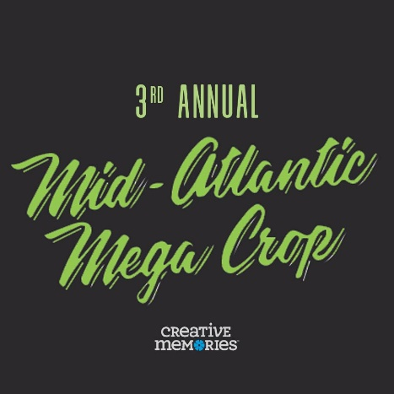

3rd Annual Mid-Atlantic MEGA Crop – Virtual ZOOM
Friday, April 16th – Sunday, April 18th, 2021
Hosted by:
Betsy Detlefs and Fellow Advisors
(we are still scheduling guest Speakers, Demonstrators and Creative Station Demonstrators so please be sure to check the website frequently)

Who should attend:
All Advisors, US and International
Advisors and their Customers, US and International
All Customers, US and International
Everyone is welcome!
Join with your Advisor, invite your Friends, or join by yourself and make a WHOLE LOT of NEW Friends!

The Mid-Atlantic Crop Includes:
3 Days of Cropping time!
Friday, April 16th, 1:00 pm, US EST through Sunday, April 18th, 2:00 pm, US EST.
Early Bird Crop Fee, now through Monday, March 1st, $69.00 USD, US Attendees, $59 USD, International Attendees (Canada, Australia, UK, but not limited to). Regular Registration, Monday, March 1st, at 11:59 pm, US EST, through Saturday, March 22nd, 11:59 pm. $89.00 USD, US Attendees, $79 International Attendees (Canada, Australia, and UK, but not limited to).

Registration ends on March 22nd, at 11:59 pm, US EST

What is included:
- Designer Classes
- Creative Stations
- Breakout Sessions
- A MEGA Goodie Bag​ (US Only)
- A Chance to win, one of three GRAND Prizes to be given away each day! (US Cash Rebate, (USD), will be sent to any International attendees that win!)
- Registrations - CLOSE on Monday, March 22nd, at 11:59 pm, so that we can begin to prepare for this event

A Supply list will be sent two weeks before the event, so that you are able to order through your Advisor, or yourself. You will have an option to order suggested new product, and/or use what you have on hand. We strongly suggest that if you are a Customer and have an Advisor, that you order through your Advisor.

The Mid-Atlantic MEGA crop is for Advisors and Customers.
International Attendees are Welcome!

Join with a group of Friends, or join by yourself, and make a WHOLE LOT of new friends. We have a whole list of talent coming your way, from across the World. There will be exclusive classes taught by CM Designers, and Advisors, along with the Creative Stations where Advisors will share their creativeness. In addition, there will be breakouts, some Business, and some not, but there will be a variety or classes that will peak your Customers interest.

This event starts on Friday, April 16th, 2021, 1:00 pm EST. That is when the fun begins! There will be around the clock cropping. Saturday event activities will start promptly at 9:00 am, US EST. Sunday event activities will start promptly at 9:00 am, US EST. The crop room will close at 2:00 pm, US EST on Sunday. We will post an agenda as the event gets closer on the website and on the Facebook Group. Be sure to check both often. Over the next couple of months, we will be posting activities, classes and breakouts, as they develop.
Communication
All communication will be through a Private Facebook Group. You will be asked to provide your Facebook ID. If you do not have a Facebook account, we are asking for you to provide an email. You can provide both if you would like. Also, the email that you will receive information from will be from diva@shopandcrop.com Please check your spam folder and be sure you are receiving our messages.

You will be considered registered once your non-refundable fee has been paid. Registration will close on Monday, March 22nd, at 11:59 pm, US EST.

Registration – Early Bird is $69.00 US (USD) Attendees, $59 USD for all International Attendees, now through Monday, March 1st pm, US EST, thereafter $89 USD for US Attendees, $79 USD for all International Attendees, until Monday, March 22nd, at 11:59 pm, US EST. That is when registration will close. You can register and pay online by going to www.shopandcrop.com and clicking onto MEGA Crop tab, or you can send a check payable to Betsy Detlefs, PO Box 1237, Germantown, MD 20875. When paying by check, please include the registration form. All funds need to be paid in US Dollars.

NO SHOWS = ABSOLUTELY NO REFUNDS! (Anyone who does not show up at the crop without prior notice will be considered a NO SHOW). If you make arrangements with someone to fill your spot, I need to know in advance. Otherwise, your replacement will not be allowed to attend. Arrangements such as these need to be handled completely between the two parties and not involve me. My only involvement will be when I am notified of the change in attendee.

QUESTIONS: contact Betsy at diva@shopandcrop.com, or text me at 240-605-8230. Please be sure to tell me who you are when you text me. You most likely will not be in my contacts.

Once you have registered, you will receive an invite for a Private Facebook Group within 1 week of registering. If you however prefer email, please let us know on the registration form. We do not want you to miss out on any juicy details.

Periodically the website will be updated with more info and I will be sending out emails as the event gets closer.

3rd Annual Mid-Atlantic MEGA Crop
Friday, April 16th – Sunday, April 18th, 2021

Name_________________________________________________

Address_______________________________________________

E-Mail ________________________________________________

Emergency Contact______________________________________

Your Advisor____________________________________________

NOTE: All contact information that is acquired through registration will only be used for this event.
____ Early Bird Option, $69 US, $59 International, Now through Monday, March 1st, at 11:59 pm.

____ Non-Early Bird, $89 US, $79 International, Sunday, March 1st through Monday, March 22nd, 11:59 pm.
I prefer communication through email:________________________

Facebook -____________________
Note: Name, or email Used on Facebook, you can
Provide both if you would like.

I realize that the fee for Mid-Atlantic MEGA Crop is non-refundable unless I personally find someone to take my space.

I Agree (please initial)

Mail this form with your payment to:
Betsy Detlefs, PO Box 1237, Germantown, MD 20875

